Raising Standards by Reading for Pleasure
Summary of Improvement Strategy and Focus
- To develop a Reading for Pleasure (RfP) culture in the school
- To increase the amount of time pupils spent reading to compensate for many pupils’ lack of out of school reading opportunities
- To ignite pupils’ enthusiasm for reading, expose them to a wide range of quality texts, and, simply, give them more time to ‘just read’
- To ensure that RfP was a feature in all guided reading lessons and complimentary to instruction
- For pupils to develop the habit of reading widely and often for pleasure and information
- To increase pupils’ vocabulary and develop them intellectually, emotionally, culturally, socially and spiritually
- To kick-start the strategy with a celebratory launch - ‘A Year of Reading’, including a new School Library and ‘Story Shed’, and lots of brand-new books!
What is going well and why
- During the 2018 summer break a room previously used mainly for storage was transformed into a beautiful, well-stocked, library. This took pupils’ breath away and has become a popular and special place. Pupils were similarly enchanted by the new Story Shed – a wonderous, cosy place, available for pupils to use at playtimes and lunchtimes, and where books change regularly.
- The inclusion of RfP as a fixture for at least one group of pupils in all guided reading lessons is now in place. This took a little getting used to (for pupils and teachers) … ‘Can reading in lessons be just be for pleasure?’… ‘Is there a catch?’ … ‘Can I really just let them read? Don’t I have to plan something for them to do to check that it’s had an impact?’
- Parents have also been inspired by the school’s ‘Year of Reading’. They have been involved in various activities and events – sharing books and reading stories to their children. Students from the local community college are regular visitors. Students read ‘bedtime stories’ to pupils and have become popular ‘reading buddies.’
- The English leader (who has driven this initiative brilliantly) has re-established links with the local library and pupils are now regular visitors. This year, many pupils have ‘signed up’ for the library’s summer reading activities (last year no-one was interested).
- Many, many, more wonderful things have happened this year to promote RfP, but it’s not possible to recount them all here.
Impact
- The new school library, the story shed and the high profile the school has given to RfP has really sparked pupils’ interest and enthusiasm. It’s difficult to measure but there’s a real feel that pupils are enjoying reading more than they did.
- New books, focusing on diversity and equalities issues, have prompted debate and supported pupils’ understanding of these issues… (character-building and awareness of the principles of fundamental British values!)
- Informal feedback from pupils has all been highly positive
- Pupils like that in guided reading sessions they now have opportunities to control their own reading and exercise their right as readers
- Pupils now realise that reading in school is not just about learning a set of skills, answering questions about what they’ve read, completing a worksheet, writing an account or a review about what they’ve read. It’s an opportunity ‘to dream with your eyes open’ and learn about interesting things … (and much, much, more of course, but we don’t need to break the spell by spelling it out!)
- Oh yes, and there’s the little fact that the school’s reading results at the end of both key stages have shot up this year! Of course, it’s not possible to know or measure the impact that this initiative has had on that but …it’s a very welcome coincidence.
Future Plans for Development
- I know that Vicky, the school’s English leader, is planning to have more ‘reading spaces and nooks’ around the school
- Pupils, particularly older pupils, are going to be hearing teachers reading aloud more often, including quite complex texts – so that they frequently hear a good model of written English spoken aloud
Tips for others
- Launch a Year of Reading and watch pupils flourish

‘Reading is to the Mind what Exercise is to the Body’

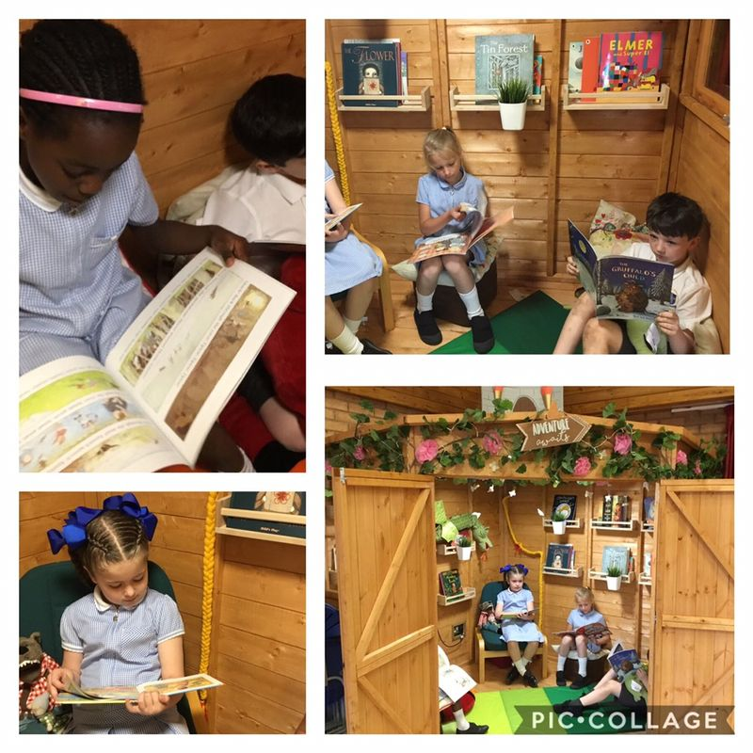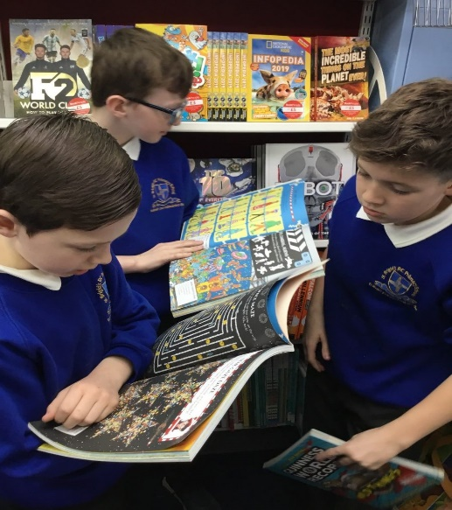
Contact details: Victoria McKay, St Brigid’s RC Primary School: 0151 477 8150

