Story time!

I’ve made a story path to show the main things that happened in the story. Can you create a story to go with the map? Use the word bank to help you.

Green group – Can you retell the story in your own word?
Yellow group – Can you write a simple sentence to match each picture starting each sentence with Bubble…
Bubble was sad. He met a butterfly. He met a frog. He was happy.
Orange/ Red group – Write a sentence to match each sentence. Try to include an adjective.
Blue group – Write two sentences to match each picture. Use extended sentences using description and connecting words such as: and/ so/ because/ but/ if

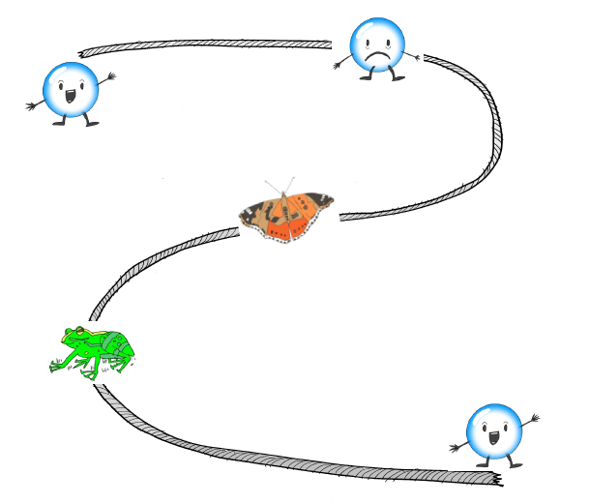

Word bank
useful glistening shimmering
butterfly garden safe beautiful

